HW1 Problem 4

a)

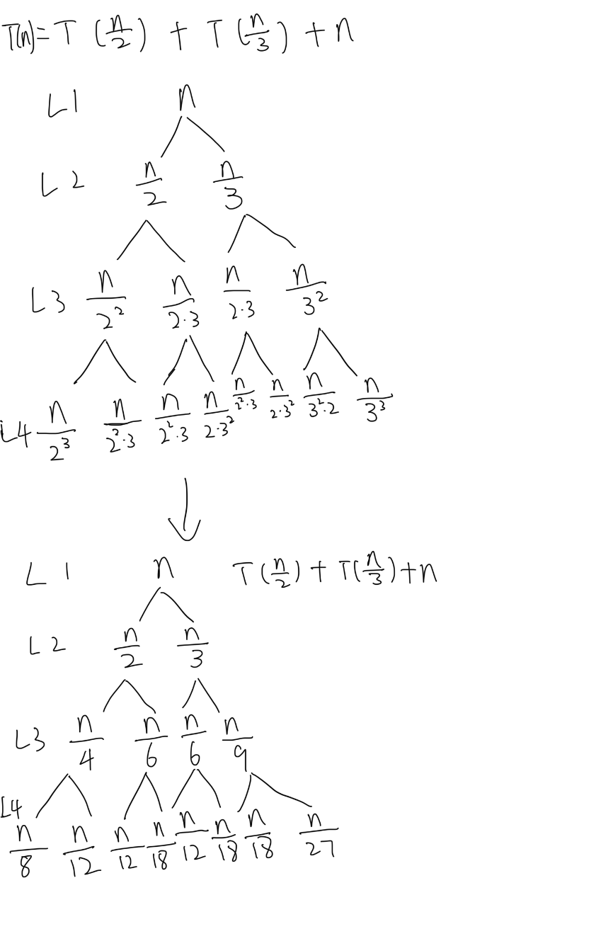

c)

